Option 1:
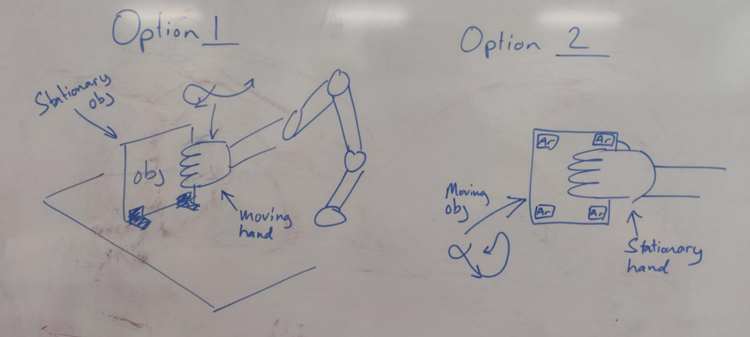
Stationary object, move hand via robot arm.
$${Δ\vec{v}}_{slip}={\vec{v}}_{hand}- {\vec{v}}_{obj}={\vec{v}}_{hand}$$
Pros:
- ${\vec{v}}_{hand}$ captured through ur_rtde. Should be plausible to observe angular velocity at every finger, ${\vec{ω}}_{finger}$, through direct forward kinematics.
- Repeatable and automatic collection of large amounts of data.
- Can lock/limit DoF to the ones of interest.
Cons:
- Only moves predefined paths.
- Potentially limited in workspace movement.

Option 2:

Station hand, move objects via human interaction.
$${Δ\vec{v}}_{slip}={\vec{v}}_{obj}- {\vec{v}}_{hand}={\vec{v}}_{obj}$$
Pros:
- More “random” movement through human movement.
- Relatively safe interaction with the shadow hand.
Cons:
- Won’t isolate DoF’s in movement. We can’t guarantee no rotation of object when only looking at $Δ{\vec{v}}_{slip}$
- ${\vec{v}}_{obj}$ can be captured through Aruco markers, but can’t be easily expanded to observe angular velocity at every finger, ${\vec{ω}}_{finger}$

